**Course: Advance Bio Informatics**

**Module Title: Variable number tandem repeats**

**Module No: 113**

Number of base pairs is not known, or the number of repeating letters in sequence is between 10-100 base pairs. Found on chromosomes and the variations in length lead to find differences between people.

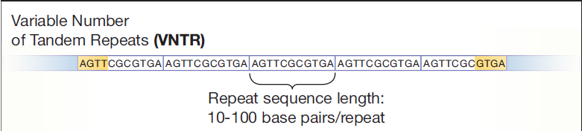

**Usage**

Connect children to their parents.

**Identity Matching:** both VNTR alleles from a specific location must match. If two samples are from the same individual, they must show the same allele pattern.

**Inheritance Matching:** VNTR alleles must follow rules of inheritance. Matching an individual with his parents/children, a person must have an allele that matches one from each parent.

**Inheritance Matching:** If the relationship is more distant, like grandparent/sibling, then matches must be consistent with the degree of relatedness.